AI WEATHERWISE
Deliver intelligent weather forecasts and insights

Description
AI WeatherWise is a RESTful backend platform built with Node.js and Express.js, using MongoDB and Mongoose ODM for data persistence. It delivers current weather metrics integrated with Google Gemini AI to provide natural-language summaries and personalized recommendations based on live conditions.
The platform features JWT authentication, bcrypt password hashing, and a set of endpoints for managing favorite locations and fetching weather insights. It includes a resilient fallback mode that keeps the API functional even without external API keys — mock weather data when OpenWeatherMap isn't configured, and rule-based text generation when Gemini isn't configured.

Scenario-Based Case Study

Background
Alex is a travel enthusiast who frequently visits different cities and needs a streamlined way to track local weather conditions and receive AI-driven suggestions based on current forecasts.

Problem
- Difficulty tracking and managing multiple favorite weather locations.
- Lack of personalized recommendations for outdoor activities or clothing.
- Need for natural-language weather summaries rather than raw data metrics.
- No secure system to store and sync favorite locations across devices.

Solution
AI WeatherWise provides a centralized service handling weather data retrieval and AI orchestration. It manages a secure User and Location database, allowing customized insights through Google Gemini, with rule-based fallbacks so the flow keeps working without paid keys.

Usage
- Registered user: manages favorite cities (CRUD), fetches real-time weather, and requests AI insights for recommendations and summaries.
- Weather application user (public): interfaces with the public weather endpoint to consume current metrics without an account.
- Developer: monitors API health via /health and verifies weather/AI service integrations using the bundled Postman collection.

Outcome
By leveraging AI and centralized data management, users spend less time deciphering raw metrics. Mongoose schemas keep the User and Location data consistent, and the Gemini integration (with its rule-based fallback) provides high-value, context-aware weather advice.

1. Software Requirements
- Operating System: Windows 10/11, macOS, or Linux (cross-platform).
- Node.js (v16 or above): runtime for the Express server.
- npm (v8 or above): dependency management.
- Gemini AI SDK: integration via @google/generative-ai for natural-language insights.
- MongoDB: document store for the Users and Locations collections.
- Postman: bundled collection (postman_collection.json) for exercising every endpoint.
- Code Editor: Visual Studio Code or similar.

2. Hardware Requirements
- Processor: Intel Core i5 (8th Gen or above) / AMD Ryzen 5 or equivalent.
- RAM: 8 GB minimum (16 GB recommended alongside a local MongoDB instance).
- Storage: 1 GB of available disk workspace.

Epic 1: Project Architecture
AI WeatherWise follows the MVC pattern to decouple business logic from data management. The Controller layer orchestrates weather fetching from OpenWeatherMap and generation of AI insights via Gemini, while the Model layer manages the User and Location entities.
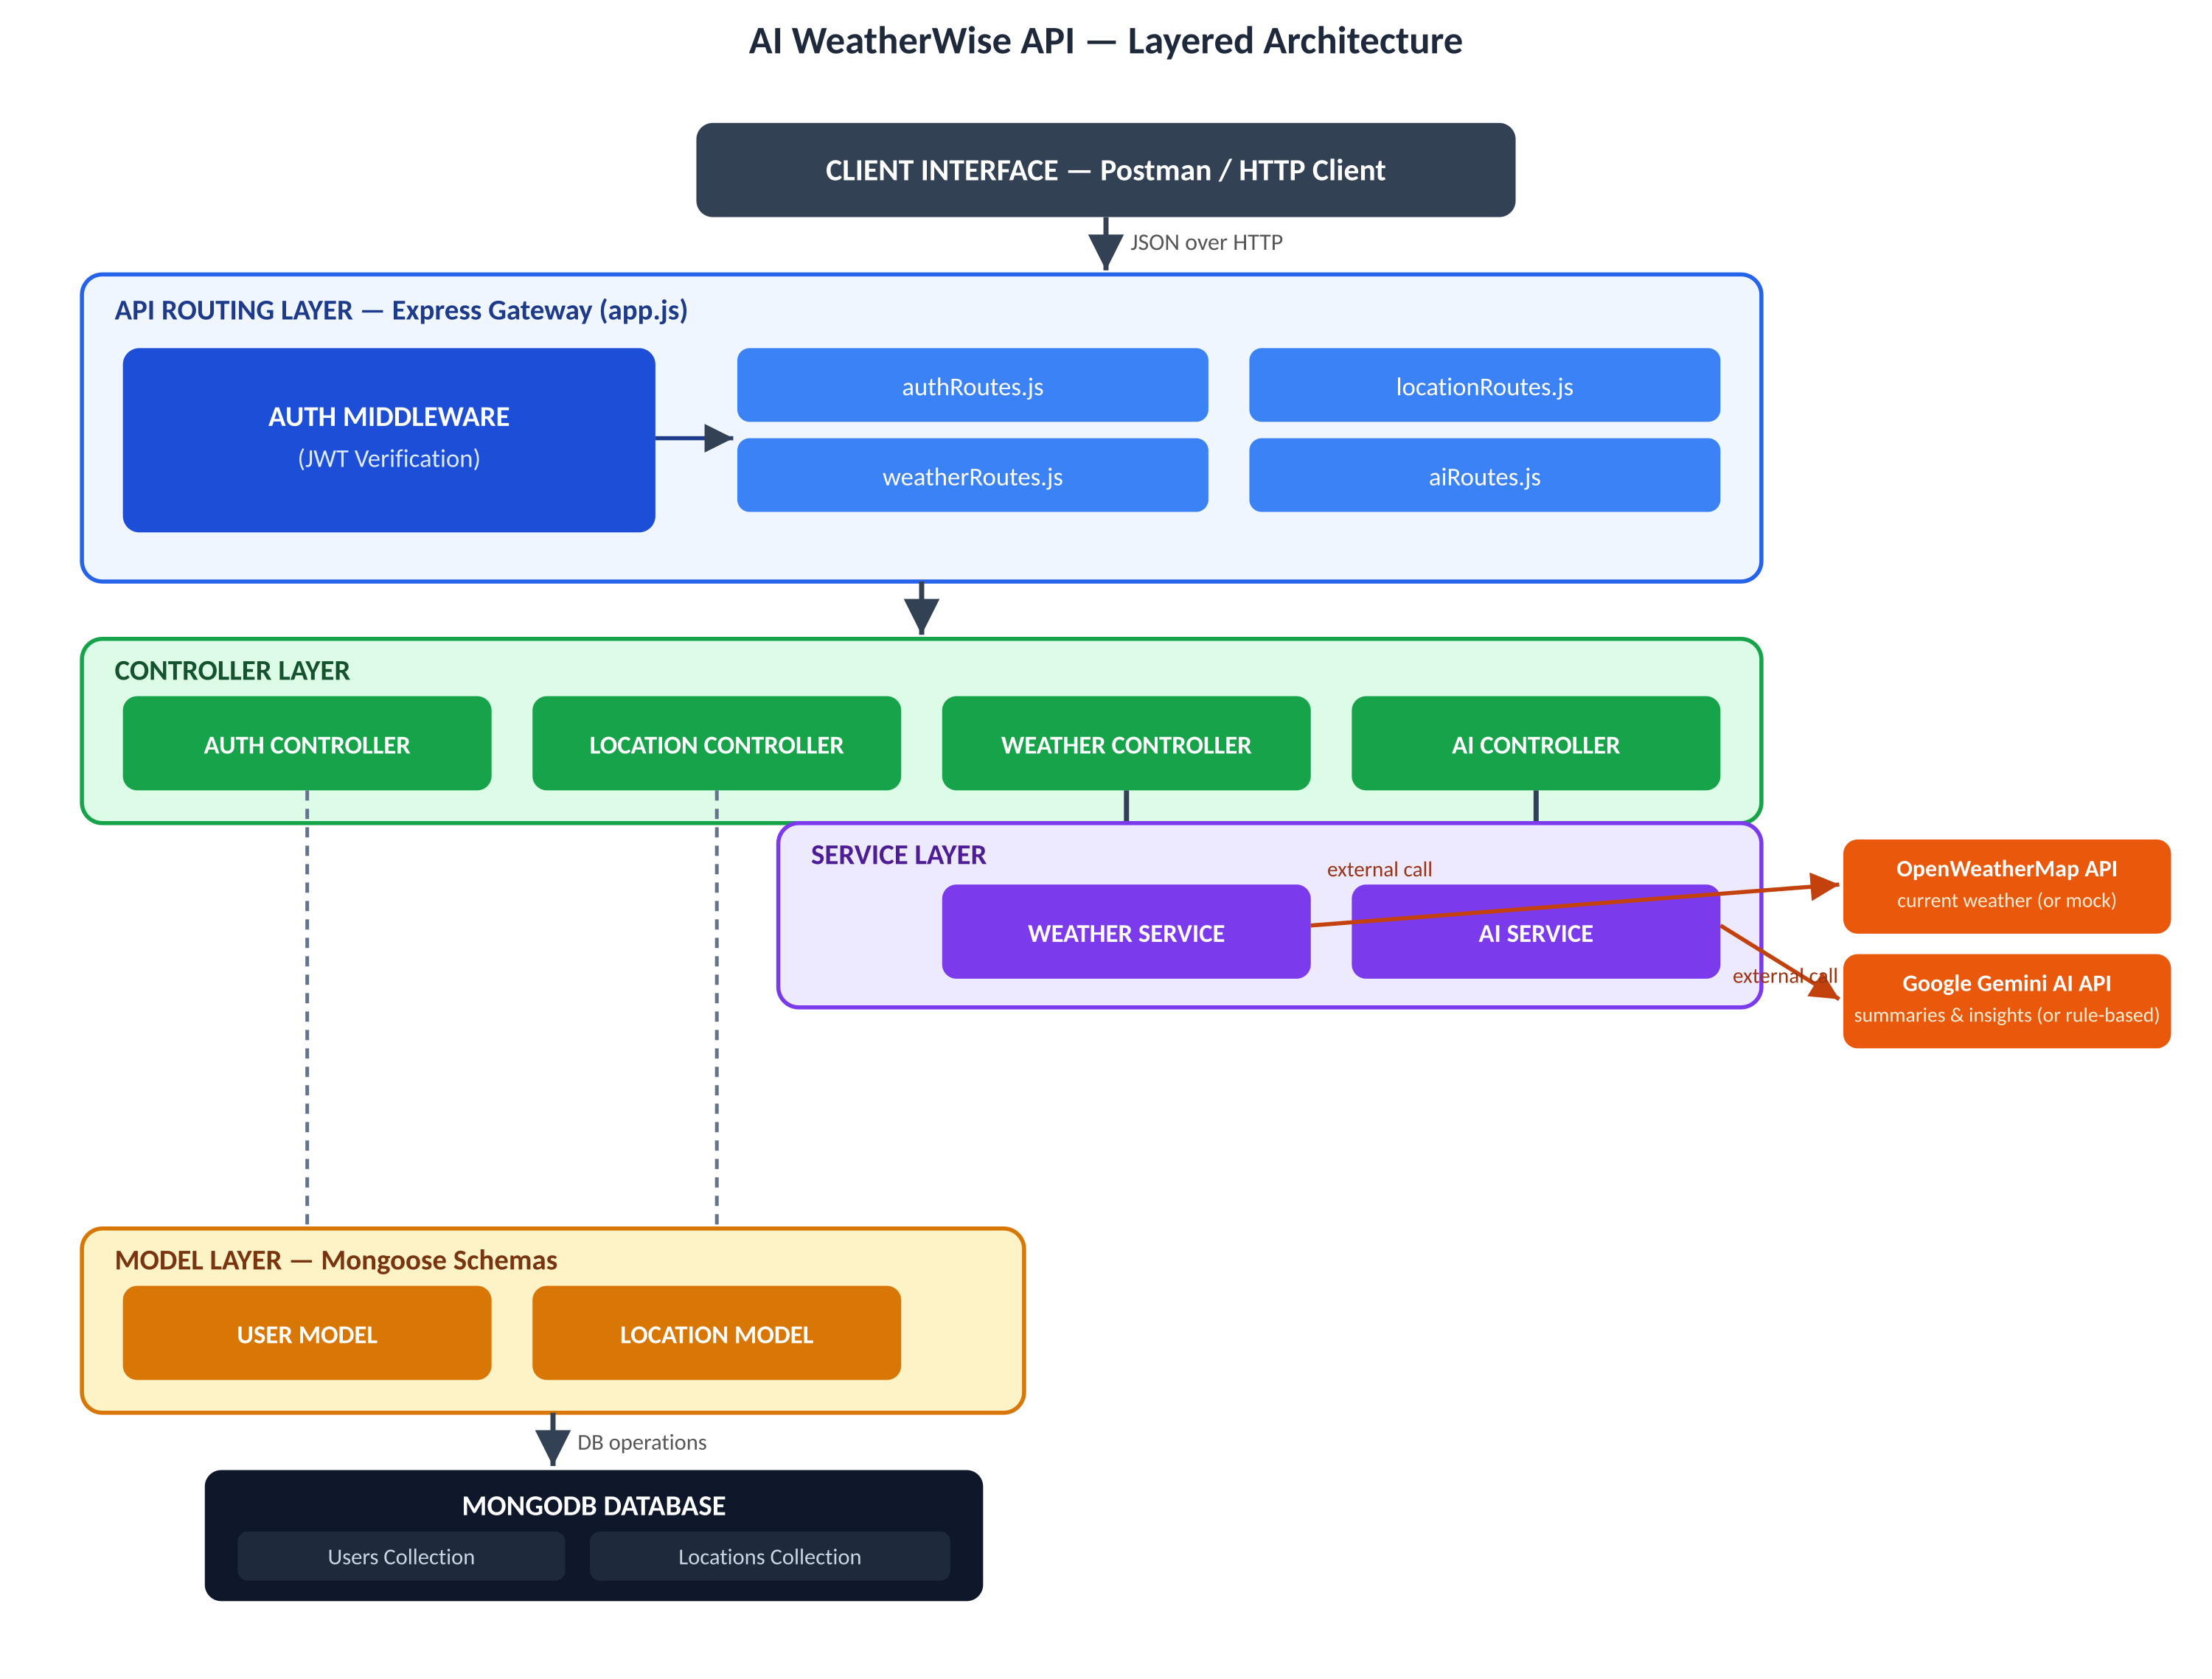

Components Definition
- Interface: Postman (or any REST client) calls the exposed routes to exchange JSON.
- Express Server Gateway: app.js parses JSON bodies, applies CORS, and mounts the auth, location, weather, and ai route modules.
- Authentication Middleware: authMiddleware.js extracts the Bearer token, verifies it with JWT, and attaches the user to the request for protected routes.
- Services (business logic): weatherService.js talks to OpenWeatherMap (or returns mock data); aiService.js talks to Gemini (or a rule-based fallback) to produce summaries, recommendations, and stories.
- Database Interface Layer: Mongoose models (User, Location) translate application logic into MongoDB operations.

Entity-Relationship (ER) Diagram
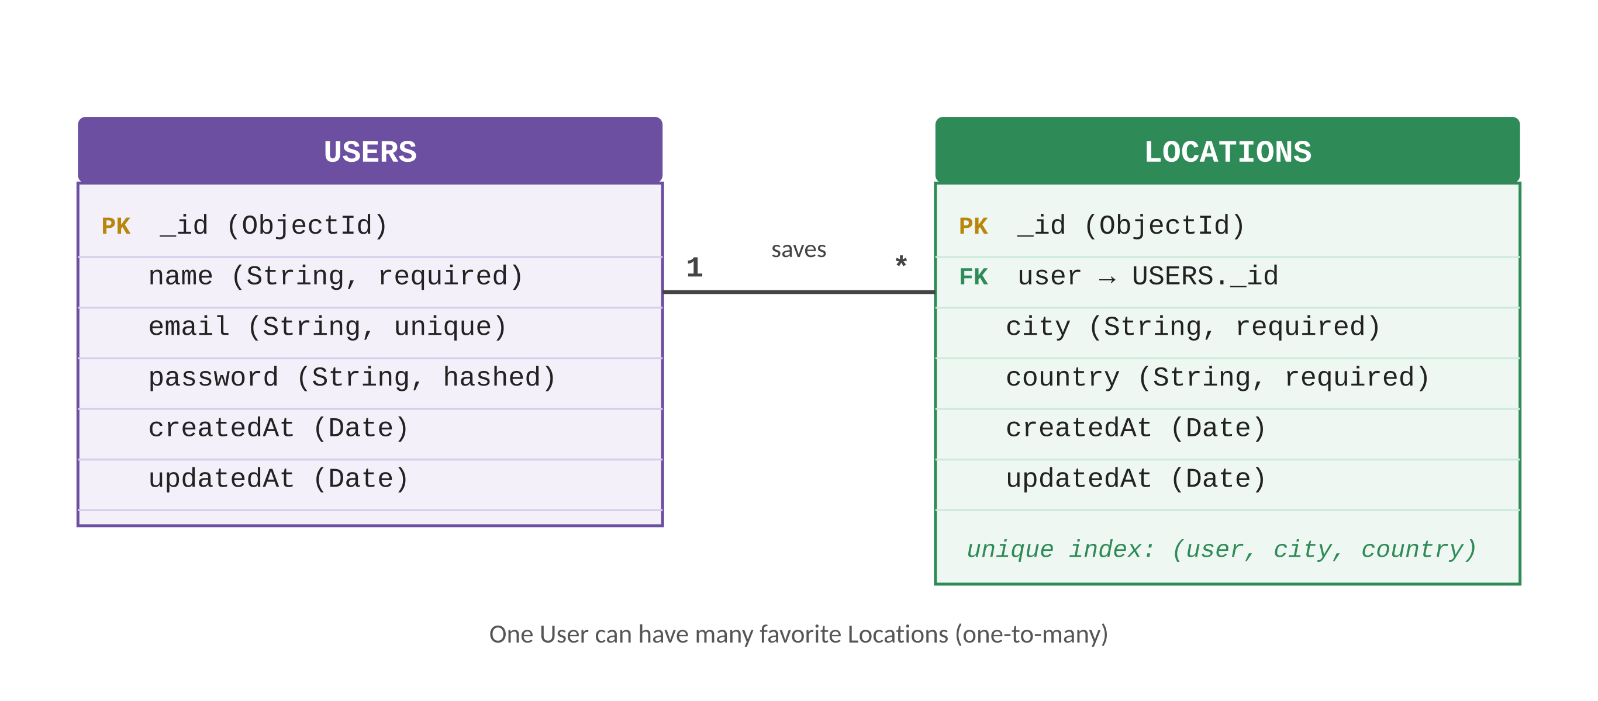

1. User Entity
- _id (Primary Key – ObjectId)
- name (String, required)
- email (String, required, unique, lowercase, validated against an email pattern)
- password (String, required, hashed with bcrypt, minimum 6 characters)
- createdAt / updatedAt (Date, via timestamps: true)

2. Location Entity
- _id (Primary Key – ObjectId)
- user (Foreign Key referencing the User collection, required)
- city (String, required, trimmed)
- country (String, required, trimmed)
- createdAt / updatedAt (Date, via timestamps: true)
- Compound unique index on (user, city, country) — a user cannot save the same city/country twice

Key Structural Mapping
- User to Location (One-to-Many): a registered user can save multiple favorite locations.

Key Features
- JWT-based route guarding: protected routes (profile, locations, AI) reject requests without a valid token.
- Favorite Location CRUD: create, list, update, and delete a user's saved cities.
- Weather retrieval with mock fallback: current conditions from OpenWeatherMap, or realistic mock data when no key is set.
- AI insight generation with rule-based fallback: Gemini-powered summaries/recommendations/stories, or deterministic text when no Gemini key is set.
- Security safeguards: bcrypt password hashing and Mongoose schema validation on every write.

Roles and Responsibilities
- Registered User: creates and maintains a list of favorite locations, initiates requests for real-time weather data, and interacts with the Gemini AI service for summaries, recommendations, and stories.
- Weather Application User (Public): consumes the public GET /api/weather/:city endpoint without needing an account.

User Flow
- User logs in or registers.
- User saves a favorite city via the Locations API.
- User fetches current weather metrics for that city.
- User requests AI-driven insights (summary / recommendation / story) based on the weather data.
- The system validates the JWT and returns the requested information.
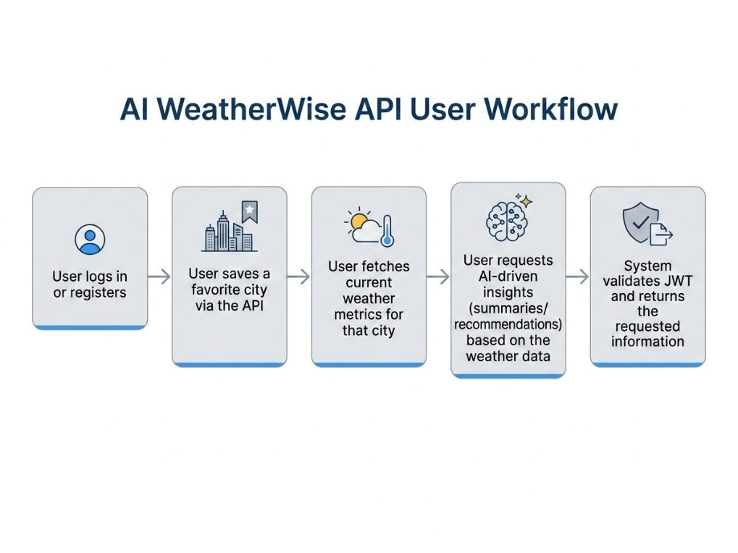

MVC Architecture Pattern

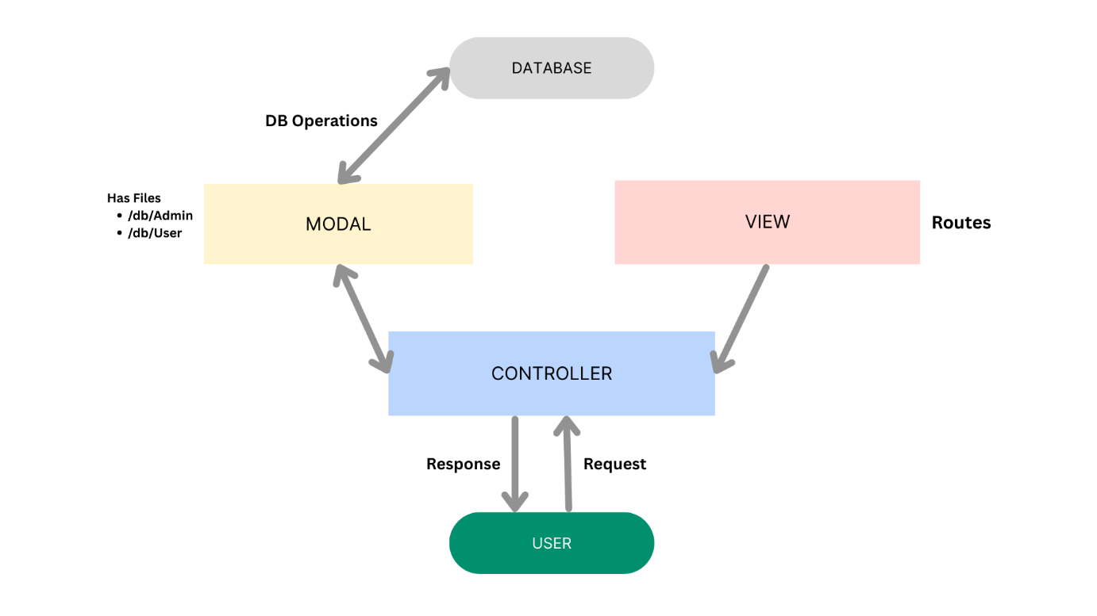
- Model Layer (Data Blueprint): Mongoose schemas (User, Location) define required fields, uniqueness, and timestamps before persistence.
- Controller Layer (Execution): authController, locationController, weatherController, and aiController validate requests, call the services, and return standard JSON responses.
- View Layer (Routing Interface): as a headless API there is no template view — the route modules (authRoutes, locationRoutes, weatherRoutes, aiRoutes) act as the interface layer, linking paths to their controller handlers.

Epic 2: Project Setup and Configuration

Creating the Project Folder
- Create a new folder named AI-WeatherWise (Backend).
- Open the project folder in Visual Studio Code.
- Initialize the project using Node.js and install the required dependencies.

Project Initialization
Open the project folder in the VS Code terminal and execute:
npm init -y
Install the required dependencies:
npm install express mongoose bcryptjs jsonwebtoken cors dotenv @google/generative-ai
Install Nodemon for development:
npm install --save-dev nodemon

Create the Following Files
- .env / .env.example
- .gitignore
- package.json
- README.md
- postman_collection.json

Create the Following Folder Structure

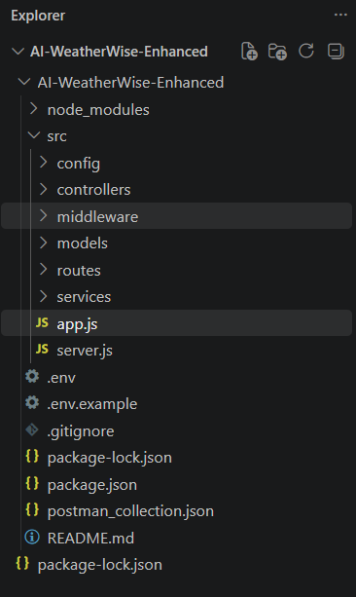

Environment Configuration
Create a .env file in the project root and configure the required environment variables:
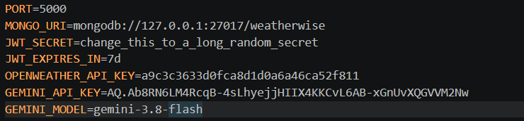

Epic 3: Backend Development
The AI WeatherWise backend is developed using Node.js, Express.js, and MongoDB, following a modular architecture. The application separates routing, controllers, middleware, models, and services to improve maintainability. It exposes secure REST APIs for authentication, favorite-location management, weather retrieval, and AI-powered insight generation.

Backend Structure
Backend/
├── .env
├── .env.example
├── .gitignore
├── package. Json
├── package-lock.json
├── postman_collection.json
├── README.md
└── src/
├── config/db.js
├── controllers/
│ ├── aiController.js
│ ├── authController.js
│ ├── locationController.js
│ └── weatherController.js
├── middleware/authMiddleware.js
├── models/
│ ├── Location.js
│ └── User.js
├── routes/
│ ├── aiRoutes.js
│ ├── authRoutes.js
│ ├── locationRoutes.js
│ └── weatherRoutes.js
├── services/
│ ├── aiService.js
│ └── weatherService.js
├── app.js
└── server.js

Core System Script Implementation

Application Entry Point (server.js)
server.js is the main entry point (declared as "main" in package.json). It loads app.js, connects to MongoDB via config/db.js, and only starts listening on process.env.PORT once the database connection succeeds:

Epic 4: Database Configuration

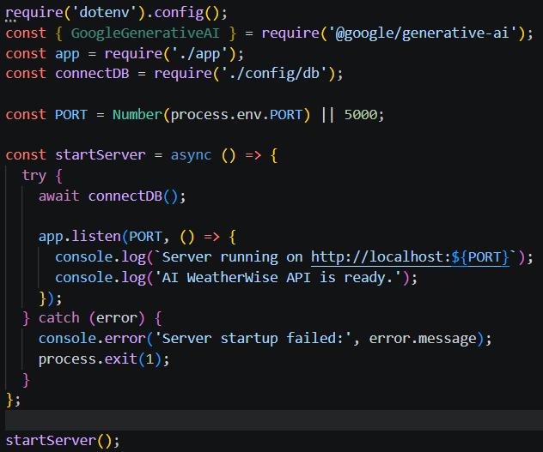

1. Configure MongoDB
- Install Mongoose: npm install mongoose
- Create the database connection (config/db.js).
- Create the Schemas & Models (User, Location).

Mongoose Schema

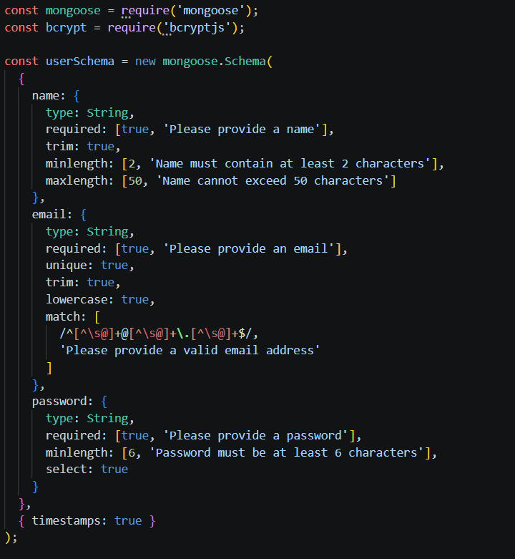

Database Connection
config/db.js establishes the connection between the application and MongoDB using Mongoose, before any client request is processed:
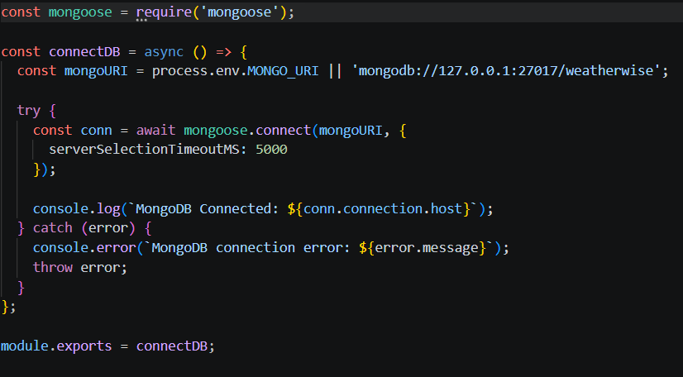

Epic 5: Project Executions
The AI WeatherWise backend can be executed locally using Node.js. Before running the application, ensure MongoDB is running and the required environment variables are configured. The backend exposes REST APIs that can be tested using the bundled Postman collection.

Running the Backend Server
Install all required dependencies:
npm install
Start the server:
npm start
For development, with auto-restart on file changes:
npm run dev
After successful execution, the server connects to MongoDB and starts listening for incoming API requests on the configured PORT (default 5000).

API Testing
Register API:
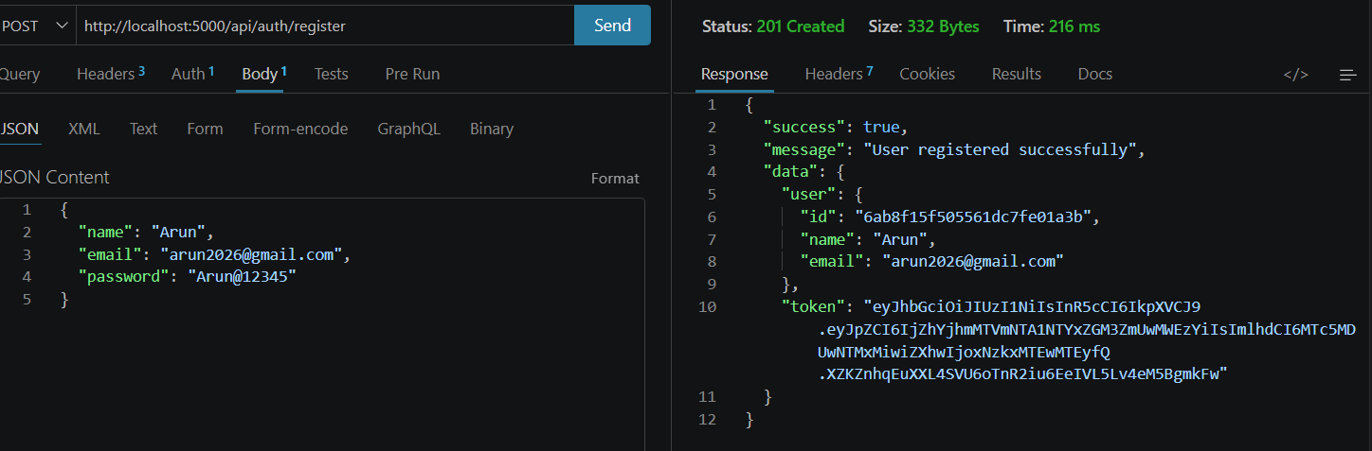
Login API:
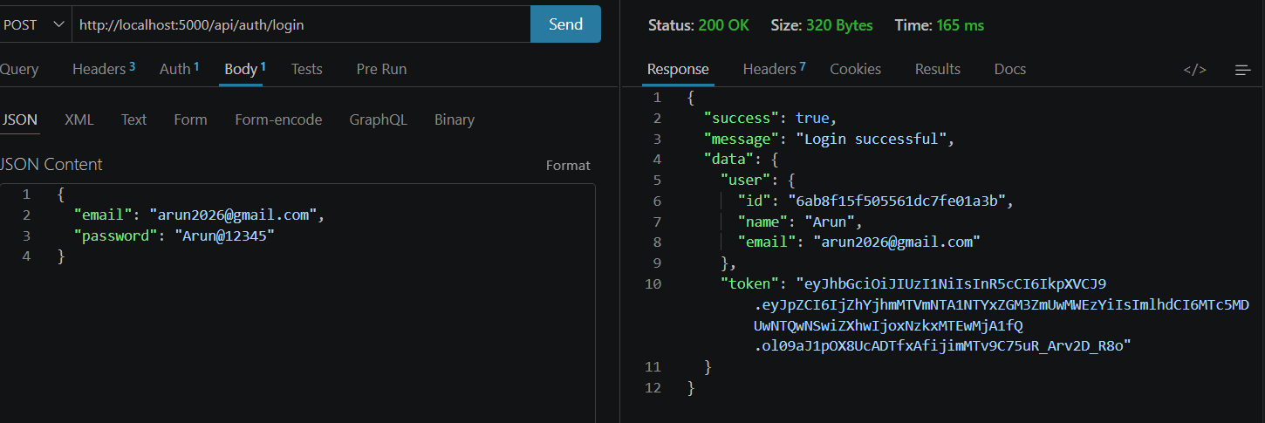
Weather API:
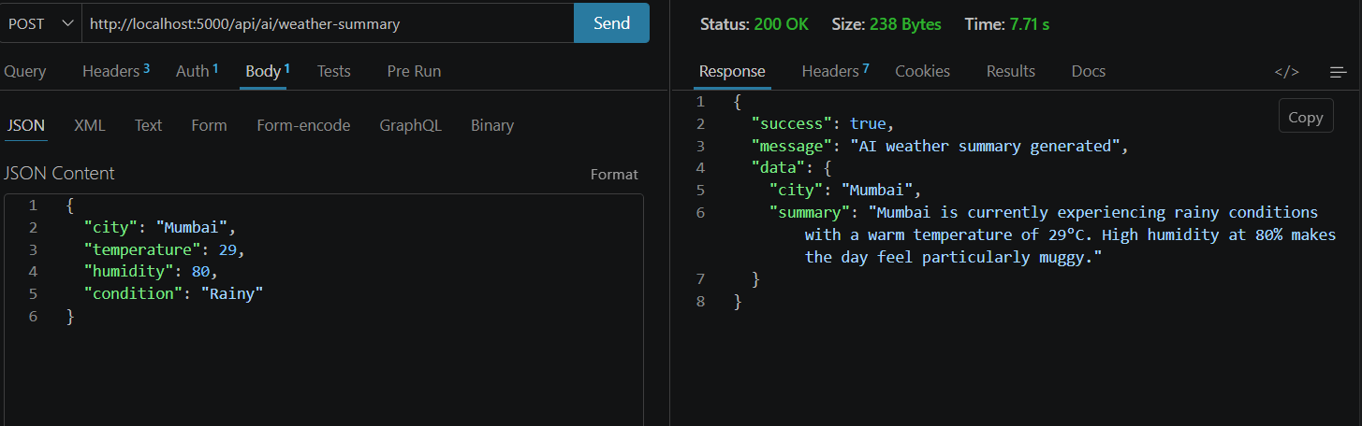
Recommendation API:
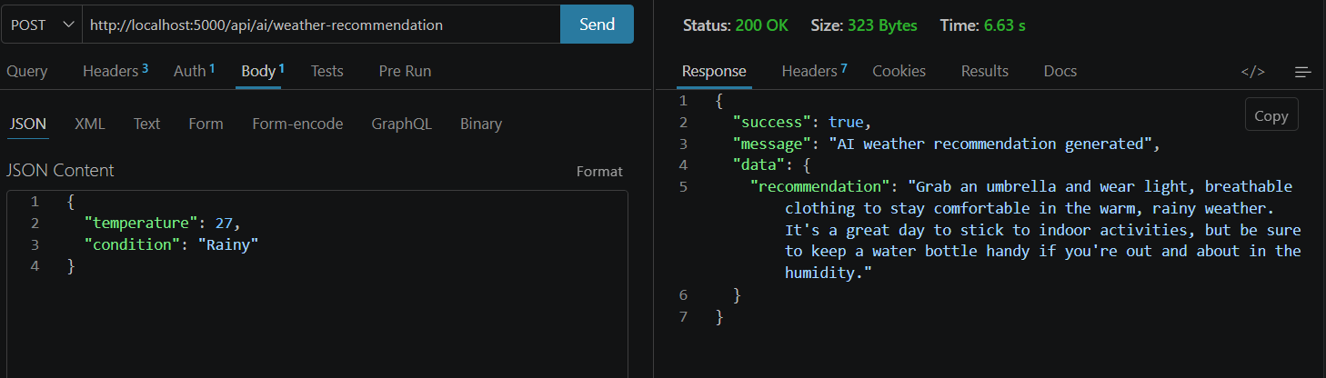
Weather story:
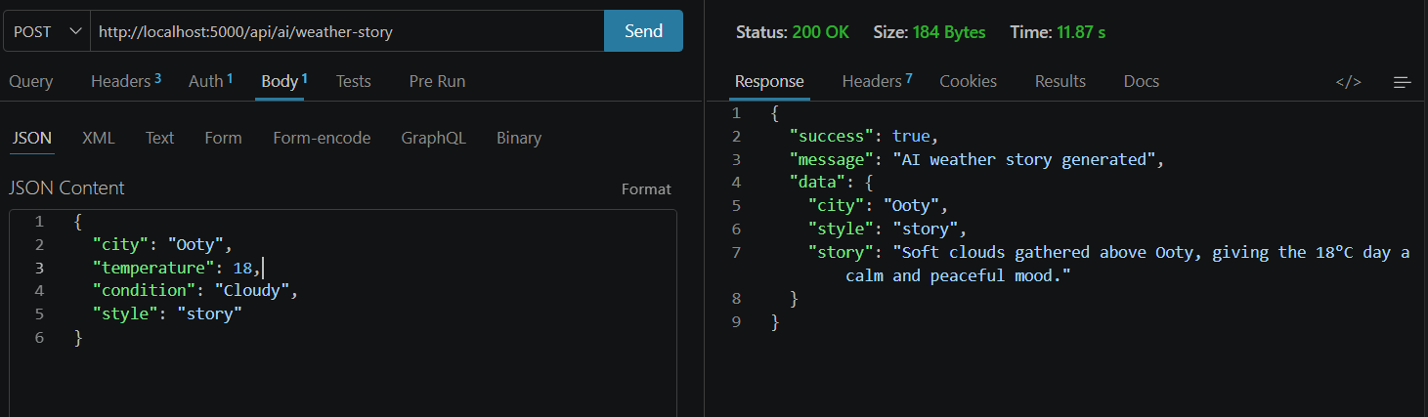
AI Chatbot:
